**Application of Lean Six Sigma in a Healthy Fast-Food Chain (Subway)**

A PROJECT REPORT

SUBMITTED TO

SVKM’S NMIMS (DEEMED - TO - BE UNIVERSITY)

**BACHELORS OF SCIENCE**

**IN APPLIED STATISTICS AND ANALYTICS**

BY:

KUSHAL DUTIA

MENTORED BY:

PROF. SUNIL SHIRVAIKER



**Certificate**

This is to certify that work described in this thesis entitled **“Application of Lean Six Sigma in Healthy Fast-Food Chain (Subway)”** has been carried out by Kushal Dutia under my supervision. I certify that this is his/her bonafide work. The work described is original and has not been submitted for any degree to this or any other University.

**Examiner**

**Date :**

**ACKNOWLEDGEMENT**

I extend my heartfelt appreciation to Professor Sunil Shirvaiker for his unwavering guidance, expertise, and encouragement throughout the duration of this project. His mentorship has been invaluable in shaping my research endeavors and fostering my intellectual growth. I am deeply grateful for his dedication to my academic development and his commitment to excellence.

Additionally, I would like to express our sincere gratitude to NMIMS’s Nilkamal School of Mathematics, Applied Statistics and Analytics (NSoMASA) for providing the resources and support necessary for the successful completion of this project. The academic environment at NMIMS’s Nilkamal School of Mathematics, Applied Statistics and Analytics (NSoMASA) has been instrumental in cultivating my passion for learning and nurturing my scholarly endeavors.

I would also like to extend my heartfelt thanks to my parents for their unconditional love, unwavering support, and endless encouragement. Their belief in my abilities has been a constant source of strength throughout my academic journey.

**CONTENTS**

|  |  |  |
| --- | --- | --- |
| **Sr. No.** | **Section** | **Page No.** |
| **1** | **Abstract** | **6** |
| **2** | **Introduction** | **6** |
| **3** | **Literature Review** | **7-8** |
| **4** | **Define Phase** | **8** |
| **4.1** | **Problem and Goal Statement** | **8-9** |
| **4.2** | **Project Scope** | **9** |
| **4.3** | **Project Plan** | **10** |
| **4.4** | **SIPOC Diagram** | **11-12** |
| **4.5** | **Process Map** | **12-13** |
| **4.6** | **Stakeholder Analysis** | **13-15** |
| **5** | **Measure Phase** | **15** |
| **5.1** | **Data Collection & Preparation** | **15-17** |
| **5.2** | **Control Charts** | **17-20** |
| **5.3** | **Pareto Chart** | **20-22** |
| **6** | **Analyze Phase** | **23** |
| **6.1** | **Root Cause Analysis(5 Why’s and fishbone diagram)** | **23-26** |
| **6.2** | **FMEA** | **26-27** |
| **7** | **Improve Phase** | **27** |
| **7.1** | **SOP & Implementation Plan** | **27-29** |
| **8** | **Control Phase** | **30** |
| **9** | **Summary & Conclusion** | **30** |
| **10** | **Limitations & Future Work** | **30-31** |
| **11** | **References** | **32** |

**1. ABSTRACT :** In today's competitive food service industry, quality, efficiency, and customer satisfaction are the most critical factors for sustaining business success. This project identifies the application of Lean Six Sigma (LSS) through the DMAIC (Define, Measure, Analyze, Improve, Control) approach method in a healthy fast food chain and Subway Atharv Pride, Vile Parle East case study. The study identifies and solves serious operations problems such as delayed delivery, high dine-in food quality complaints, and wrong order fulfillment. With the analysis of data, delayed deliveries were raised from 20.1% for 2023-24 to 25.9% for 2024-25, dine-in food quality complaints were 22%, and wrong order deliveries were doubled from 17% to 34%, leading to inefficiency and customer dissatisfaction. To solve these problems, there was a scientific approach followed for the measurement of inefficiencies, identification of the root cause, and process improvement. Rationalization of operations, workflow optimization, and quality control and communication process improvement were among the high-priority areas that were targeted. Preliminary findings show spectacular improvement in order accuracy, food quality consistency, and speedy delivery times, which confirm the fact that Lean Six Sigma tools can be applied effectively in the fast-food business to achieve operational excellence without compromising on speed, quality, and customer satisfaction.

**2. INTRODUCTION :**

The quick-service restaurant (QSR) sector has witnessed exponential growth in recent years fueled by evolving consumer attitudes toward convenience and healthy food consumption. Despite this, operational efficiency, food quality, and customer satisfaction are a problem for most QSRs. Delays in food preparation and delivery, varying food quality, and order mistakes are some of the factors that lead to customer dissatisfaction and higher operational costs(Jones, Parast, and Adams 2010). Faced with these challenges, companies are embracing Lean Six Sigma (LSS) practices to streamline processes, reduce waste, and enhance overall service efficiency

Lean Six Sigma is a fact-based approach that integrates Lean philosophies (removal of waste and optimization of flow) with Six Sigma techniques (removal of variability and defects) to maximize process efficiency and customer satisfaction(Costa et al. 2020). The DMAIC (Define, Measure, Analyze, Improve, Control) approach is widely used in Lean Six Sigma projects to detect and remove process inefficiencies in a systematic way(Pande, Neuman, and Cavanagh 2007). In the quick-service industry, implementation of Lean Six Sigma can lead to reduced service times, reduced food wastage, and increased order accuracy (Antony 2006).

This Lean Six Sigma research study is applied in a healthy food chain business through a case study of Subway Atharv Pride, Vile Parle East. The project addresses three critical issues: late delivery, high complaints on dine-in food quality, and high wrong order deliveries. Applying Lean Six Sigma concepts, the research seeks to maximize order processing, quality inspection, and delivery performance, thereby improving customer satisfaction and operational excellence.

**3. LITERATURE REVIEW :**

|  |  |  |  |
| --- | --- | --- | --- |
| **Paper Name** | **Author Name** | **Year** | **Methodology** |
| Six Sigma for service processes | Antony, J. | 2006 | Case study-based approach examining LSS implementation in service industries, including QSRs. |
| A framework for effective six sigma implementation. | Jones , Parast and Adams | 2010 | Implementation of Sigma in quality Management Process |
| The effect of Lean Six Sigma practices on food industry performance: Implications of the Sector's experience and typical characteristics | Costa et al. | 2020 | Mixed-method study using data analytics and case studies of QSRs implementing LSS. |
| Challenges in Implementing Lean Six Sigma in Fast Food Chains | Brown, L., Smith, T., & Wilson, R. | 2019 | Qualitative research identifying barriers to LSS adoption in QSRs. |
| The Six Sigma Way: How GE, Motorola, and Other Top Companies are Honing Their Performance | Pande, P. S., Neuman, R. P., & Cavanagh, R. R. | 2007 | Methodological framework explaining the DMAIC approach for process improvements. |

**4. DEFINE PHASE :** The Define Phase establishes the foundation for process improvement through clearly defining problems, goals, and project scope. It contains a Problem & Goal Statement to define key issues and desired outcomes, and a Project Scope to define boundaries. A Project Plan gives timelines and milestones, and a SIPOC (Suppliers, Inputs, Process, Outputs, Customers) diagram displays the overall workflow. Lastly, a Stakeholder Analysis identifies key players involved to align and support the project.

**4.1 PROBLEM & GOAL STATEMENT :**

* **Problem Statement No.1 :** Late deliveries increased from 20.1% in 2023-24 to 25.9% in 2024-25(10 months) , resulting in lower customer satisfaction score.
* **Goal Statement No.1 :** Reduce late deliveries from 25.9% to 13% or less by end of Quarter 3 2025 .

* **Problem Statement No.2 :** ​​Complaints on dine – in food quality remain high at 22% in the current financial year. That is 22 in 100 people complain about the quality of food at the store.
* **Goal Statement No.2 :** Reduce complaints from 22% to 11% or less by Quarter 3 2025.

* **Problem Statement No.3 :** ​​Wrong order deliveries doubled from 17% in 2023-24 to 34% in 2024 – 25, increasing rework and dissatisfaction.
* **Goal Statement No.3 :** ​​Cut wrong orders from 34% to 17% or less by Quarter 3 2025.

**4.2 PROJECT SCOPE :**

**In Scope:**

* **Process Improvements** – Improving order processing, food preparation, and delivery efficiency.
* **Food Quality Improvement** – Identifying and elimination of food quality issues.
* **Staff Training** – Making kitchen and counter staff more efficient and accurate.
* **Performance Indicators** – Defining KPIs on service time, food quality, and order accuracy.
* **Customer Feedback Analysis** – Collection and actioning of customer feedback.  
    
  **Out of Scope:**
* **Menu Changes** – No deviation from Subway's regular menu.
* **Infrastructure Upgrades** – No major store renovation or equipment upgrade.
* **Third-Party Delivery Logistics** – Cannot manage Swiggy/Zomato operations internally.
* **Corporate Policy Updates** – Aligning with Subway's global standards.

**4.3 PROJECT PLAN :**

|  |  |  |
| --- | --- | --- |
| **Phase** | **Key Activities** | **Timeline** |
| Define | -Validate problem and goal statements.  - Finalize project scope. - Create a SIPOC diagram.  - Create Process Map  - Stakeholder Analysis | December 2024  &  January 2025 |
| Measure | - Gather historical records of deliveries, food quality, and order fulfillment.  - Control Charts  - Pareto Charts | February 2025 |
| Analyze | - Perform Root Cause Analysis ( 5 Why’s)  - Fishbone diagram  - FMEA (Failure modes and effect analysis) | March 2025 |
| Improve | - Making a SOP and a training plan at subway | March 2025 |
| Control | - Monitor performance | April 2025 and beyond |

**4.4 SIPOC DIAGRAM :** The above figure is a SIPOC diagram of Subway restaurant, which outlines the most critical components of the order fulfillment process. It encircles Suppliers (ingredient, beverage, and packaging suppliers), Inputs (raw materials such as bread, vegetables, and sauces), Process (order taking activities to food preparation and payment), Outputs (freshly prepared sandwiches, packaged meals), and Customers (walk-in customers, online customers, corporate customers). This aids process flow understanding, key stakeholders, and areas for improvement.

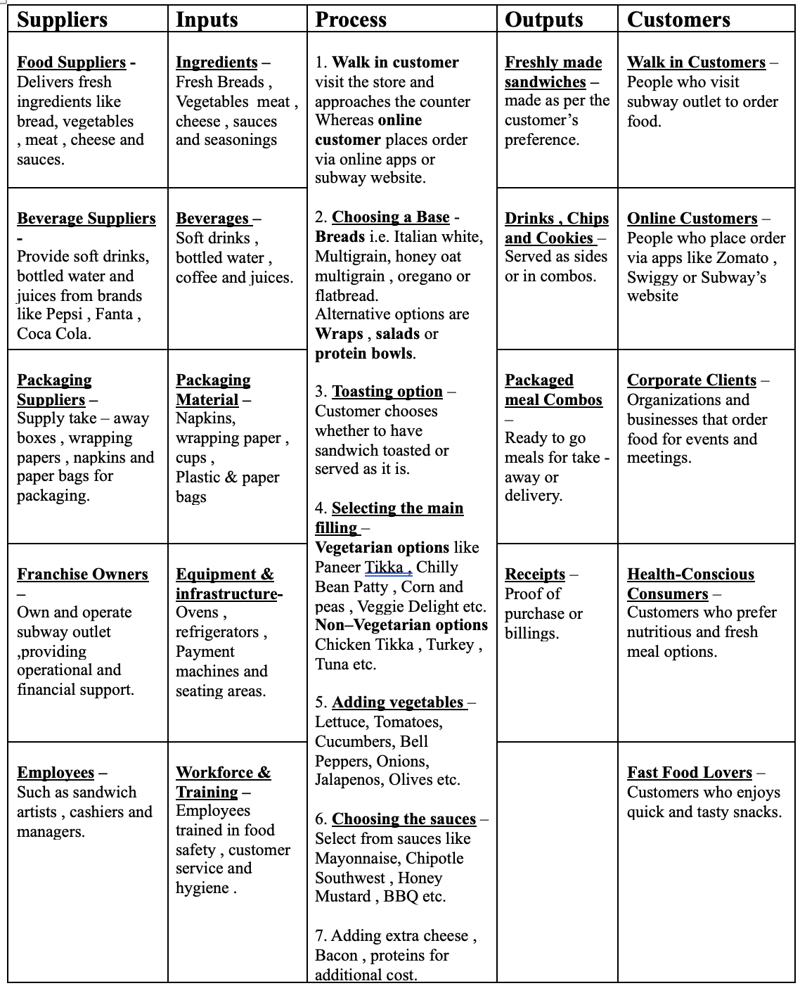

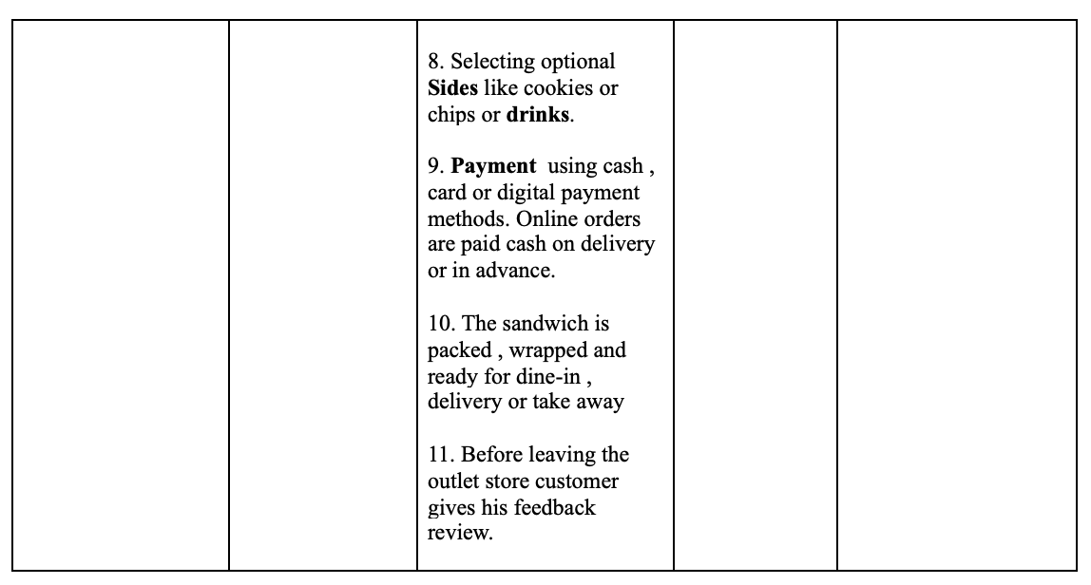

**4.5 PROCESS MAP :** The process map shows the customer journey and order fulfillment process in the Subway store, both dine-in and delivery. The process starts from a customer visit to the store or ordering via online. Preparation of the order consists of a sequential step: base selection (bread, wrap, salad, etc.), main filling and vegetables, sauces and extra toppings, and optionally converting to combo. The sandwich is toasted (if needed), seasoned and topped with extra protein, and served dine-in or packed for delivery. The process is finalized with payment and receiving customer feedback.

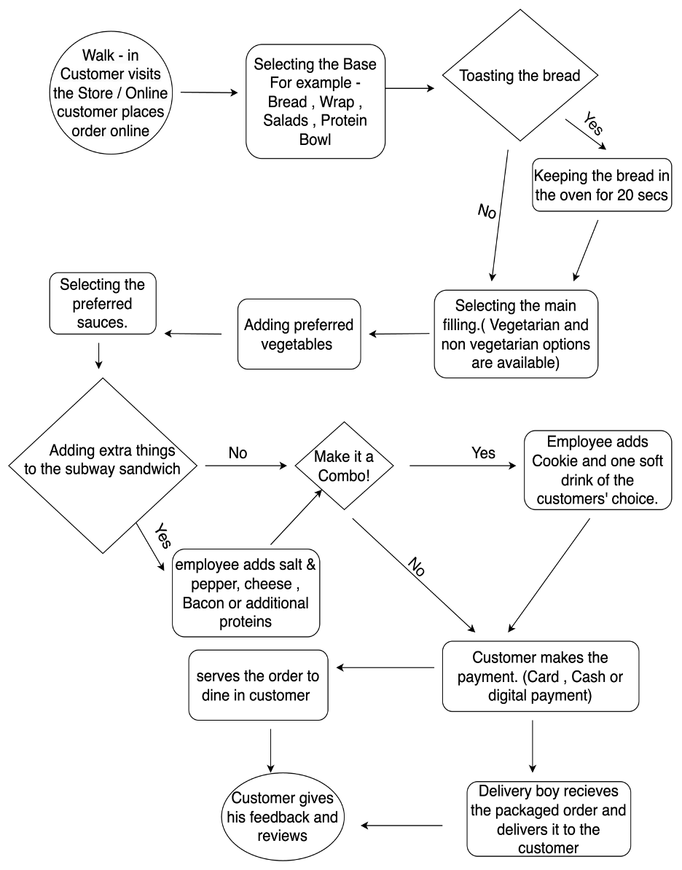

**4.6 STAKEHOLDER ANALYSIS :** The following Stakeholder Analysis Matrix categorizes key stakeholders in the Subway Lean Six Sigma project according to role , degree of influence, impact, key issues, and engagement approach. It categorizes key decision-makers like the Store Owner and Manager, working-level team members like Counter and Kitchen Staff, external stakeholders like Corporate Subway, Delivery Partners (Swiggy/Zomato), and Suppliers, and end-users (Customers). It categorizes high-impact stakeholders for active involvement and medium to low-influence stakeholders for frequent update

|  |  |  |  |  |  |
| --- | --- | --- | --- | --- | --- |
| **Stakeholder** | **Role/Interest** | **Impact** | **Influence** | **Key Concerns/Expectations** | **Engagement Strategy** |
| Store Owner/Franchisee | Primary decision-maker with financial stake in outcomes | High | High | Profitability, operational efficiency, brand reputation | Regular progress updates; focus on ROI and financial metrics |
| Store Manager | Day-to-day implementation of changes; team leadership | High | High | Staff productivity, smooth operations, customer satisfaction | Active involvement in team meetings; responsible for staff training and compliance |
| Counter Staff | Direct customer interaction; order processing | High | Medium | Fast service, customer satisfaction, accurate order processing | Training sessions; incentive programs for improvement suggestions |
| Kitchen Staff | Order preparation; quality control | High | Medium | Food quality, hygiene standards, efficiency | Process improvement workshops; feedback collection on operational challenges |
| Corporate Subway | Brand standards; approval for certain changes | Medium | High | Compliance with brand guidelines, product consistency | Monthly reports on progress; ensure compliance with brand guidelines |
| Customers | End users of the service | High | Medium | Food quality, pricing, service experience | Feedback surveys; communication about improvement initiatives |
| Delivery Partners (Swiggy, Zomato) | Order fulfillment; customer acquisition | High | Medium | Timely deliveries, packaging quality, service ratings | Collaboration on delivery timing; feedback on packaging |
| Suppliers | Ingredient quality and delivery | Medium | Low | Timely payments, consistent orders, quality control | Communication about any process changes affecting order volumes |

**5. MEASURE PHASE :** Measure Phase of Lean Six Sigma is just gathering and analyzing the data along with creating a baseline for a process's performance. It ensures the improvement is measured on the basis of facts, not assumptions. The significant tasks include key measures identification, measuring the existing performance, and process variations or defects identification.We utilized Data Collection in our study to track process performance, Control Charts to track trends for late delivery and wrong order, and Pareto Analysis to identify the most serious causes of the problems. These tools provided us with clear images of process inefficiencies such that we were able to prepare for improvement

**5.1 DATA COLLECTION AND PREPARATION :** The data used for this study was collected from a Subway outlet in Atharv Pride, Vile Parle East, for two financial years: 2023-24 and 2024-25 (10 months).

Each dataset has 9 key columns:

* **Date** – Represents the end of each month.
* **Total Orders** – The total number of customer orders received.
* **Problem Orders** – Orders that had issues, including late deliveries, wrong items, or complaints.
* **Late Delivery** – Number of orders delivered after the expected time.
* **Dining Quality** – Number of dine-in customers who reported dissatisfaction with food quality.
* **Staff Behavior** – Number of complaints related to staff service.
* **Table Cleaning** – Number of complaints about unclean tables.
* **Wrong Order Delivered** – Number of orders where the wrong items were delivered.
* **Miscellaneous** – Other minor customer complaints or issues.

**For 2023 - 24**

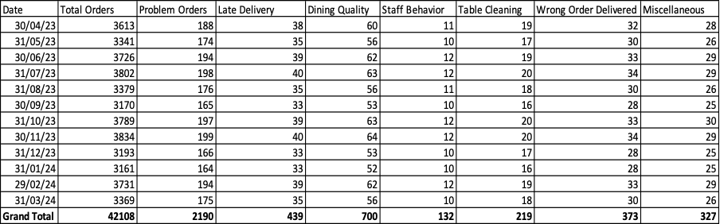**For 2024 - 25 (till february)**

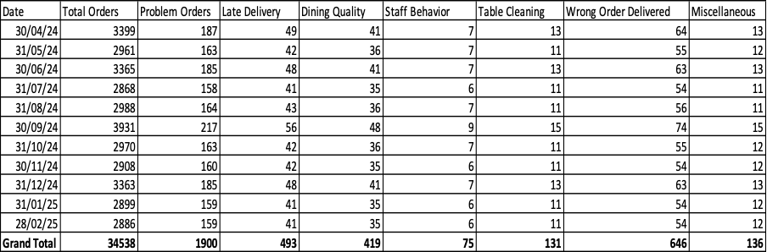

**Problem Percentage Distribution :**

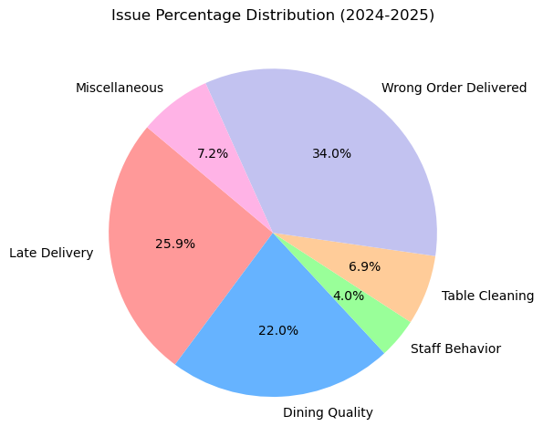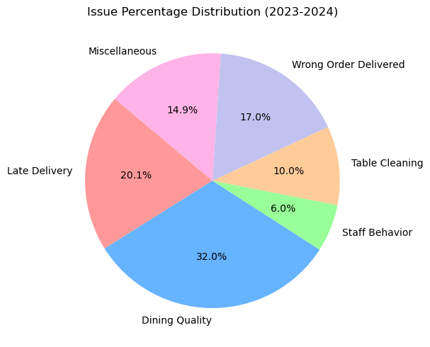

**5.2 CONTROL CHART :** Control charts are a statistical process control tool that is used to monitor variation and stability in processes over time. Control charts for incorrect orders received and delayed deliveries in this research help detect trends, reveal inconsistencies, and ascertain whether the processes are in control.

* **Blue Line (Data Points)** – The number of late deliveries for the month.
* **Green Dashed Line (Mean)** – The average rate of late deliveries over the period.
* **Red Dashed Line (Upper Control Limit - UCL)** - The level at or above which variation is unacceptable and must be acted upon immediately.
* **Orange Dashed Line (Lower Control Limit - LCL)** – Lower variation limit (defined to prevent negative values).

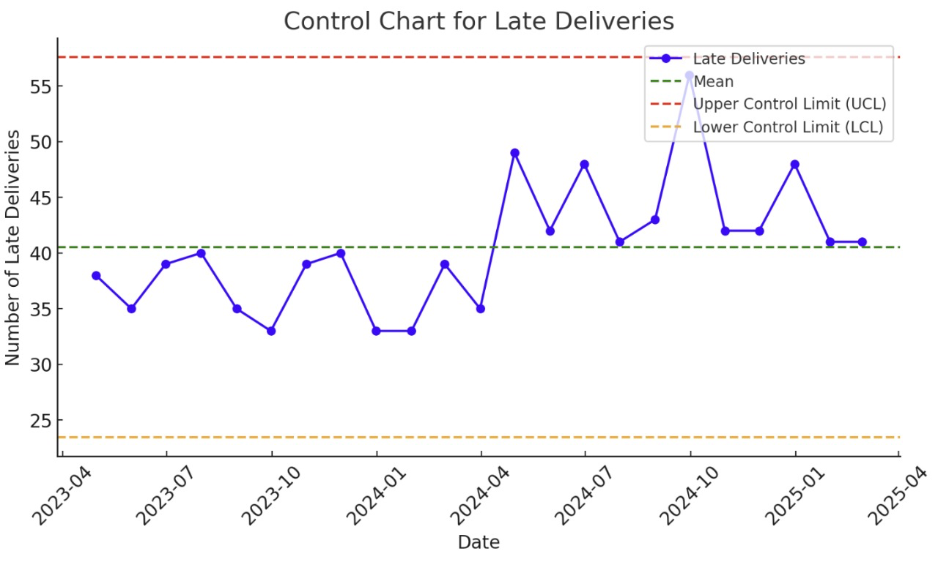

**Outcome :**

1.⁠ Process is under control - No points fell below the Upper Control Limit (UCL) or above the Lower Control Limit (LCL). This implies there are no notable unexpected variations in late deliveries.

2. Persistent Increase in Late Deliveries - Within limits, the trend indicates a rising movement in late deliveries over time. This could be indicative of systematic inefficiencies. i.e., kitchen sluggishness, lack of staff, or poor route planning.

3. There is Common Cause Variation - The oscillations shown on the graph are likely the result of chronic, long-term inefficiencies, not random spikes. Improving process inefficiencies can decrease the average number of delayed deliveries.

4. Improvement Opportunity Exists - Since the process is stable but not at the desired level, Lean Six Sigma techniques could help reduce delivery delays.

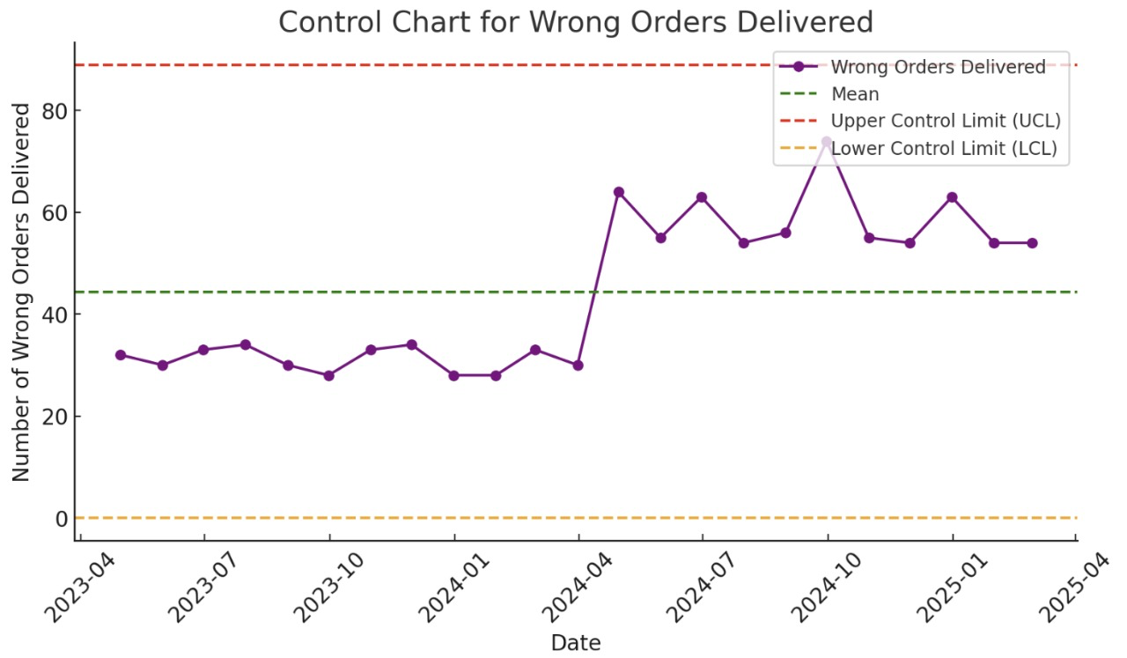

**Outcome :**

1. Process is Under Control - No points plotted outside the Upper Control Limit (UCL) or below the Lower Control Limit (LCL).This means wrong order deliveries are stable with time without excessive volatility.

2. Gradual Increase in Wrong Orders - Even though under control limits, wrong orders have been on the rise over time. This implies systematic problems in order-taking, assembly, or verification operations.

3. Common Cause Variation Exists - The variation in incorrect orders is consistent, i.e., errors are occurring because of a process inefficiency and not due to random failures. Potential causes: miscommunication during order-taking, double-checking not being done, or employee training deficiencies.

4. Opportunity for Process Improvement - Although the process is stable, the aim should be to reduce the average number of incorrect orders. Process standardization, visual checking, and automation can minimize errors in the long run.

– Neither late deliveries nor wrong orders are entirely out of control, but both show significant variation that requires improvement. Thus we need to reduce the overall variation instead of focusing on UCL exceedance.

**5.3 PARETO CHARTS :** A Pareto Chart is a technique that supports the 80/20 rule, illustrating how 80% of problems stem from 20% of reasons. It is utilized to identify and rank the most significant sources of a problem in order for businesses to focus on the most impactful improvements. Pareto charts for Dine-in quality, Wrong order delivered and Late deliveries are created in order to unveil the causes of these issues.

**Dine - in Quality –**

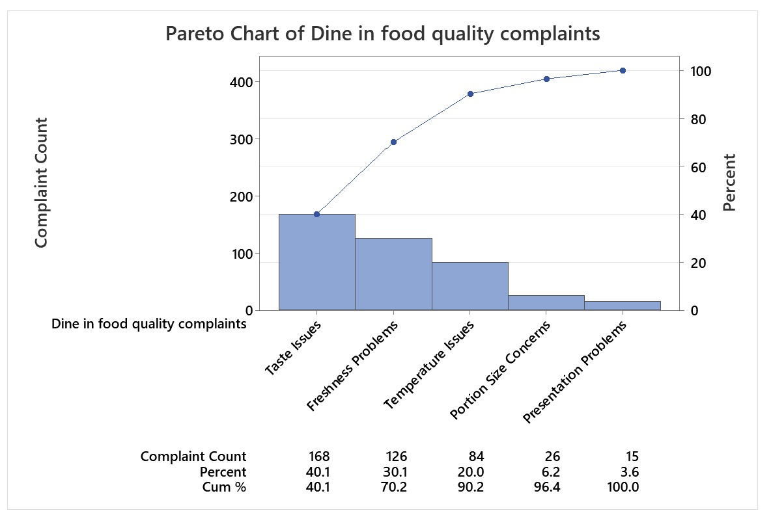

* Taste Issues (40%), Freshness Problems (30%), and Temperature Issues (20%) together contribute 90% of total food quality complaints.
* This confirms that Taste, Freshness, and Temperature are the biggest problem areas, more than 80% of total complaints , aligning with the Pareto Principle. (80/20 Rule).
* Portion Size and Presentation Problems have minimal impact, making them lower-priority improvement areas.

**Wrong Order Delivered –**

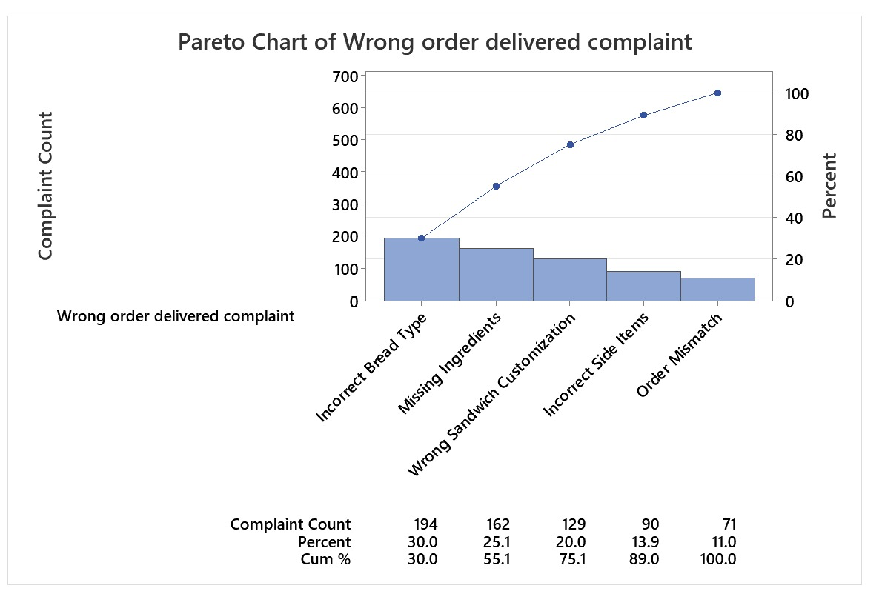

* Incorrect Bread Type(30%) , Missing Ingredient(25%) , Wrong sandwich customization(20%) together contribute to 75% of the total wrong order delivery problem.
* The highest three problems (Incorrect Bread Type, Missing Ingredients, and Wrong Customization) contribute 75% of all wrong orders. This closely follows the 80/20 principle, showing that few causes make up most of the mistakes.
* Incorrect side items and Order mismatch (Digital Errors) have minimal impact making them lower priority improvement areas

**Late Deliveries –**

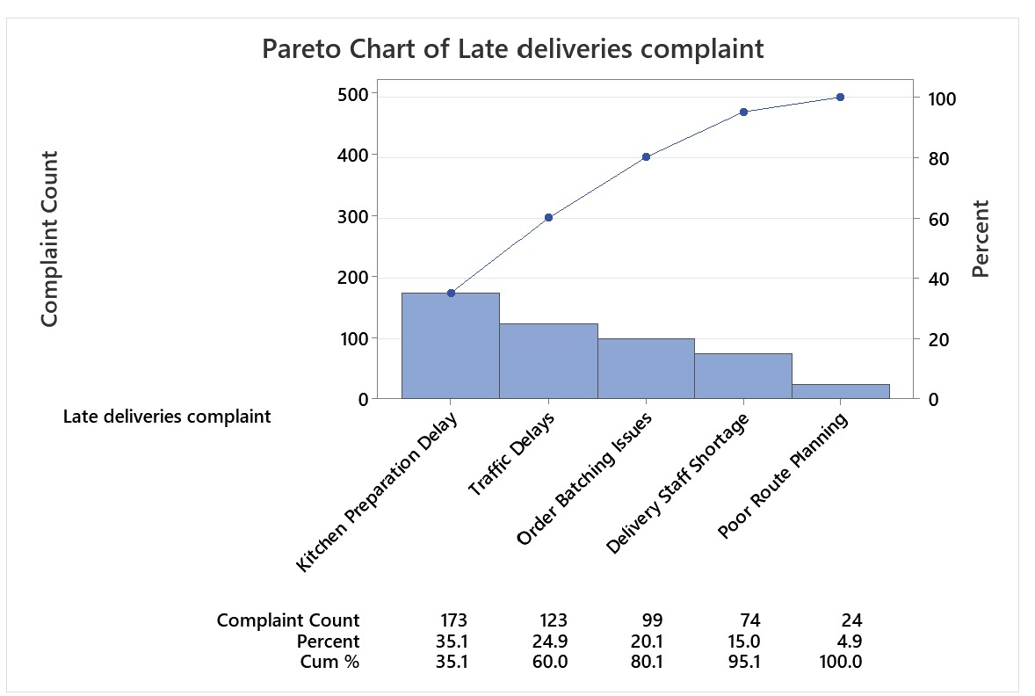

* Kitchen Preparation Delay(35%) , Traffic Delays(25%) , Order Batching Issues(20%) together contribute to 80% of the total Late Delivery Problems.
* The highest three problems Kitchen Preparation Delay, Traffic Delays and Order Batching Issues are biggest problem areas contributing to 80% of the problems. Aligning with Pareto (80/20 Principle).
* Delivery Staff Shortage and Poor Route Planning have minimal impact making them lower priority improvement areas.

**6. ANALYZE PHASE :** The Analyze Phase of Lean Six Sigma is all about determining the root causes of process inefficiencies and defects. In this phase, data gathered in the Measure Phase are examined to determine the causes of significant problems. In my project, I applied Root Cause Analysis (5 Whys) to break down the root causes of late delivery, order errors, and food quality problems. I also conducted Failure Mode and Effects Analysis (FMEA) to examine potential areas of failure, prioritize risks, and determine which problems required immediate action. This systematic process ensured the improvement effort was focused on the root causes and not symptoms, laying the groundwork for solutions to thrive in the Improve Phase.

**6.1 ROOT CAUSE ANALYSIS ( The 5 Why’s Analysis and Fishbone Diagram)**

Root Cause Analysis (RCA) is a systematic approach to identifying the root causes of a problem, and not just treating its symptoms. It helps organizations eliminate recurring problems by addressing their root causes.

In this study, we utilized 5 Whys Analysis to identify the root causes of late deliveries, wrong orders, and poor-quality food so that we could develop evidence-based improvement solutions.

**Dine - In Food Quality Complaints (22%) → Target (11%)**

1. Why are customers complaining about freshness?

* Because some ingredients taste stale or spoiled.

1. Why are ingredients stale in taste?

* Since they were not properly stored or consumed after their expiration date.

1. Why are ingredients stored inappropriately?

* Because of different refrigeration temperatures and not always applying FIFO.

1. Why is the refrigeration temperature different?

* Because of poor care, and constant opening of the refrigerators.

1. Why does maintenance fluctuate ?

* As there is no standardized preventive maintenance schedule for refrigeration equipment.

**Root Cause:** Poor storage procedures and lack of equipment maintenance.

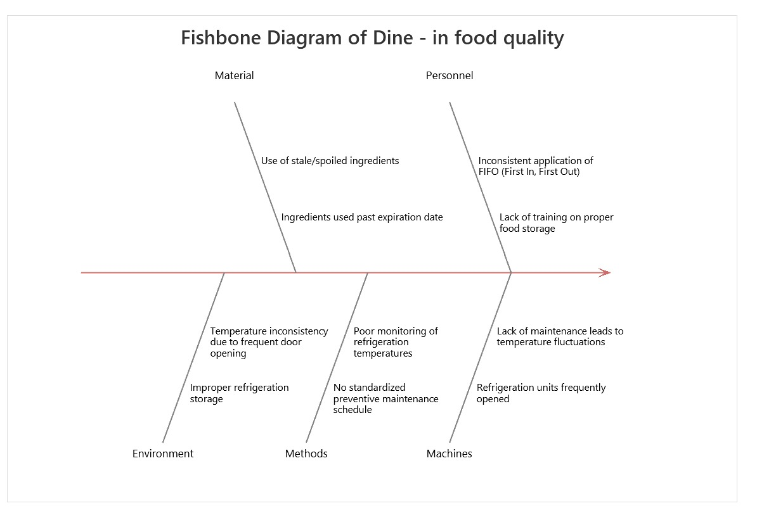

**Wrong Order Delivered Complaints (34%) → Target(17%)**

1. Why are the customers receiving the incorrect bread?

* Since the workers use the wrong kind of bread.

1. Why would they select the wrong bread?

* Because they don't comprehend the order or depend on voice instructions.

1. Why do they get orders wrong?

* Because there is no validation step before sandwich assembly.

1. Why is there no verification process?

* Because the kitchen workflow favors speed over precision.

1. Why is speed prioritized over accuracy ?

* Because there are no definite SOPs (Standard Operating Procedures) that necessitate a double-check system.

**Root Cause:** Inadequate employee training and order verification.

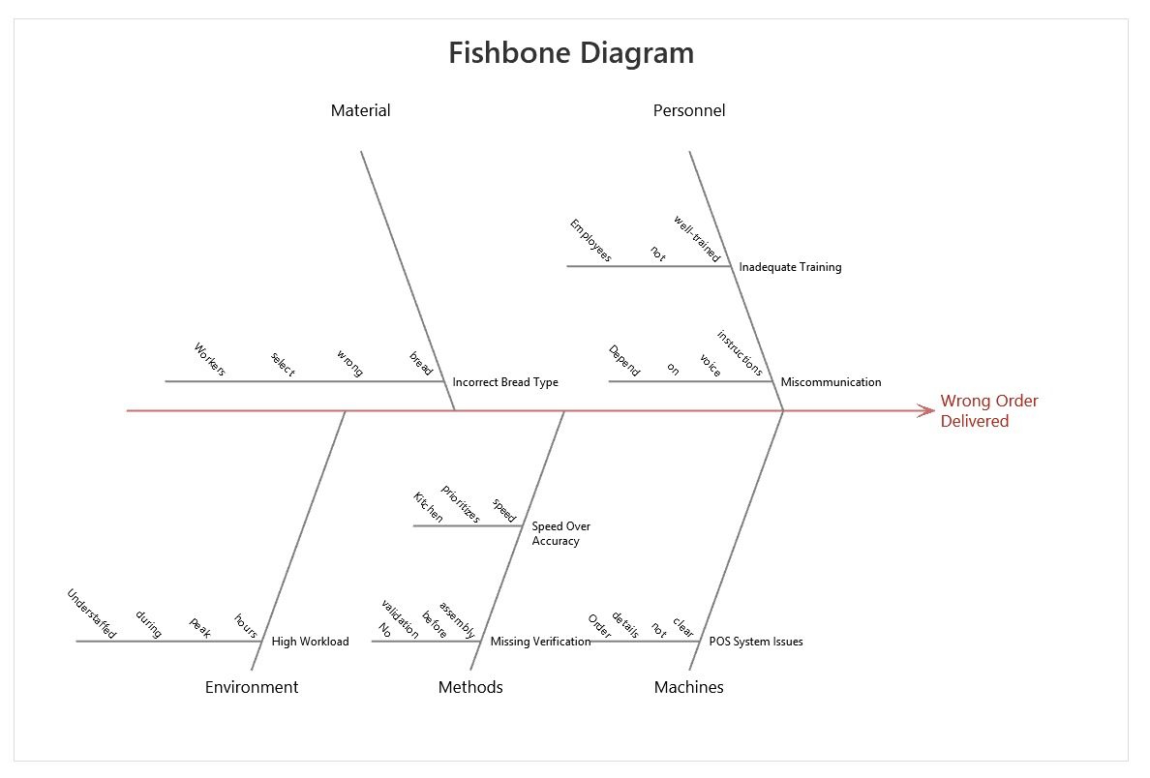

**Late Deliveries Complaints ( 25.9 %) → Target ( 13%)**

1. Why are deliveries late?

* Because preparing food is too time-consuming.

1. Why is preparation taking so long?

* Since the kitchen staff are plagued by ingredient shortages and inefficient workflow.

1. Why do ingredient shortages occur?

* Because the inventory is not replenished in the first place, and the FIFO method is not practiced.

1. Why is inventory restocking inefficient?

* As there is no organized inventory control system.

1. Why is there no tracking system?

* Because inventory control is manual, there are delays and errors.

**Root Cause:** Ineffective kitchen workflow and absence of inventory management.

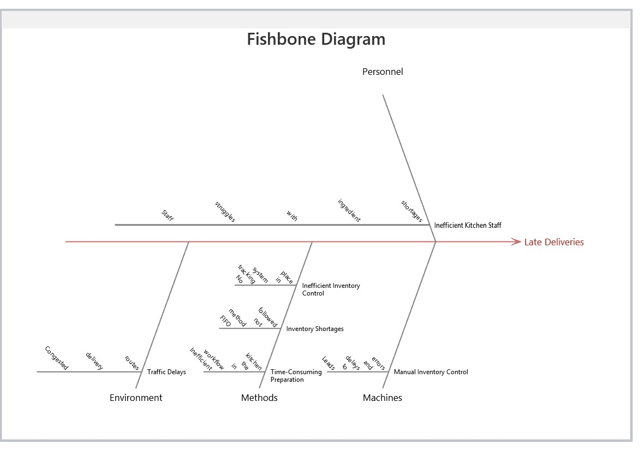

**6.2 FAILURE MODES AND EFFECT ANALYSIS (FMEA) :**

To identify and address the most important operational problems, I conducted a Failure Modes and Effects Analysis (FMEA) for Late Deliveries, Wrong Orders, and Food Quality Complaints. I carefully reviewed potential areas of failure and assigned Severity, Occurrence, and Detection ratings based on logical assumptions, industry research, and trends. From these ratings, I calculated the Risk Priority Number (RPN) to prioritize important problems. A higher RNP indicates that those issues must be prioritized for fixing the problem.

Risk Priority Number (RPN) = Severity(S) X Occurrence(O) X Detection(D)

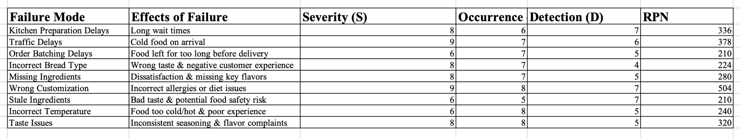

**OUTCOME :**

1. Since Wrong Customization has the highest RNP score ie. 504 we can say that it is the most critical failure mode which requires a double check process before customization.
2. Late Deliveries are primarily caused by Traffic delays with RNP score of 378 which means that route optimization and GPS tracking is required.
3. Food Quality Complaints rise from Taste issues with RNP of 320 and missing ingredients with a RNP of 280 which requires standardization of recipes and better inventory.

**7. IMPROVE PHASE :** The Improve Phase of Lean Six Sigma is intended to implement solutions which eliminate the reasons for the defects and inefficiencies identified during the Analyze Phase. It is a significant phase to confirm that there are measurable process improvements leading to enhanced performance, fewer errors, and better customer satisfaction.

**7.1 STANDARD OPERATING PROCEDURE (SOP) :**

**Location :** Subway Atharv Pride Branch , Vile Parle East

**Prepared by :** Kushal Dutia

**Date :** 26 / 03 / 2025

**Purpose :**

This SOP aims to standardize critical processes at Subway Atharv Pride to improve service efficiency, minimize errors, and increase customer satisfaction. The key areas of focus include:

* Decreasing late deliveries (from 25.9% to 13% by Q3 2025)
* Decreasing dine-in food quality grievances (from 22% to 11%)
* Decreasing erroneous delivery orders (34% to 17%)

|  |  |  |  |
| --- | --- | --- | --- |
| **Process** | **Responsible Person** | **Steps** | **Quality Check** |
| Order placement | Customer | Walk-in customers order online or go to the store. | Check order receipt in the system. |
| Selecting the base | Sandwich artist | Customer chooses one of the options such as Bread, Wrap, Salad, or Protein Bowl. | Double-check selection before proceeding. |
| Toasting the bread | Sandwich artist | if asked for, warm the bread in the oven for 20 seconds. | Watch for toasting time. |
| Selecting the main filling | Sandwich artist | Provide vegetarian and non-vegetarian as per the menu. | Ensure proper portioning. |
| Adding vegetables | Sandwich artist | Add requested vegetables according to the customer's demand. | Ensure freshness and portion control. |
| Selecting sauces | Sandwich artist | Apply chosen sauces in the right amount. | Avoid excessive use or absent sauces. |
| Adding extras  (optional) | Sandwich artist | Customer can ask for extra cheese, bacon, salt & pepper, or other proteins. | Check and charge extra if necessary. |
| Making it a combo  (optional) | Cashier/Sandwich artist | If ordered, include a cookie and a soft drink in the order. | Check correct combo items. |
| Order completion | Sandwich artist / Delivery Staff | Dine-in: Deliver the order to the customer.  - Delivery: Wrap the order correctly and give it to the delivery staff. | Double-check order before handover. |
| Payment | Cashier | Customer pays by Card, Cash, or Digital Payment. | Check transaction completion. |
| Customer feedback | Customer / Store Manager | Customers leave feedback and reviews after consuming | Take note of feedback for improvement. |

**Training plan :**

|  |  |  |
| --- | --- | --- |
| **Training Module** | **Topics Covered** | **Training Method** |
| SOP overview | Why SOPs matter, effect on efficiency. | Presentation & Discussion |
| Order accuracy & billing | Order error reduction, correct payments. | Role - playing & hands on training |
| Food Prep & hygiene standards | Portion control, freshness. | Live demonstration |
| Reducing delivery errors | Order verification, online order handling. | Case study & simulation |
| Customer service & feedback | Complaint resolution, customer experience enhancement. | Role playing |

**8. CONTROL PHASE :**

During the Control Phase, we will concentrate on maintaining and tracking the gains accrued in the Improve Phase to guarantee long-term success. KPIs like late delivery rates, incorrect order percentages, and food quality complaints will be monitored regularly through control charts and process audits. Measures like Standard Operating Procedures (SOPs) mechanisms will be instituted to avoid repeating errors. We will also gather customer feedback and employee suggestions to detect any deviations and take corrective measures if necessary. Monthly reviews will guarantee efficiency and guarantee that the desired process improvements are maintained over time.

**9. SUMMARY & CONCLUSION :**

This project was designed to enhance operational effectiveness within the restaurant by minimizing late deliveries, wrong order deliveries, and dine-in food quality problems through the application of the Lean Six Sigma DMAIC approach. During the Measure Phase, data gathering, Pareto analysis, and control charts were utilized to determine the scope of the problems. The Analyze Phase involved Root Cause Analysis (5 Whys) and Failure Modes and Effects Analysis (FMEA) to determine the root causes of inefficiencies. During the Improve Phase, Standard Operating Procedures (SOPs) were established to simplify the process and avoid repetitive errors.

In the Control Phase, we will track with control charts, audits, and performance monitoring to maintain gains over time. The most important deliverable of this project is a systematic process to improve customer satisfaction, decrease errors, and improve service efficiency. Through the systematic elimination of inefficiencies and reinforcement of best practices, we anticipate achieving our objective of decreasing late deliveries, miss orders, and food quality complaints by 50% or more by Q3 2025.

Overall, the project proves the capability of Lean Six Sigma tools to bring quantifiable improvement in a service industry and establish a culture of ongoing process improvement.

**10. LIMITATIONS :**

* **Data Availability & Accuracy:** The study was based on the available data, which may not have captured all the real variations in activities.
* **Implementation Challenges:** Although SOPs measures were intended to reduce errors, uniform application by all employees is promoted by training and behavioral modification, and effectiveness can be hindered by resistance to change.
* **External Factors:** Some of the problems, such as delayed deliveries, may be due to external factors such as traffic, weather, or third-party delivery partners that the restaurant cannot control.
* **Restricted Root Cause Analysis Scope:** The 5 Whys and FMEA tools pointed out major failure areas, but additional statistical analysis (e.g., DOE - Design of Experiments) would tell us even more about how we could further optimize the process.
* **Control phase not yet Implemented** - Since control phase will be executed in the future , its long term effectiveness has not been validated. Ongoing monitoring will be required to measure stability.

**FUTURE WORK :**

* **Full Control Phase Implementation:** Implement systematic surveillance through a system of control charts, process audits, and ongoing observation of data for ongoing improvement.
* **Real-Time Order & Delivery Tracking:** Use RFID or GPS-based tracking to track order flow and delivery efficiency, minimizing uncertainty over delivery timelines.
* **AI & Predictive Analytics for Demand Forecasting:** Utilize data-driven AI solutions to predict peak hours, ingredient needs, and delivery wait times, optimizing operational efficiency.
* **Customer Feedback Integration:** Ensure there is an organized feedback mechanism (survey, sentiment, VOC programs) tomeasure customer satisfaction directly contributing to process improvements.
* **Long-Term Employee Training & Process Standardization:** Regular workshops and regular refresher training for employees to ensure continuous compliance with SOPs, error-proofing techniques, and best practices.

**11. REFERENCES :**

Antony, Jiju. 2006. “Six Sigma for Service Processes.” *Business Process Management Journal* 12(2):234–48. doi: 10.1108/14637150610657558.

Costa, Luana Bonome Message, Moacir Godinho Filho, Lawrence D. Fredendall, and Gilberto Miller Devós Ganga. 2020. “The Effect of Lean Six Sigma Practices on Food Industry Performance: Implications of the Sector’s Experience and Typical Characteristics.” *Food Control* 112:107110. doi: 10.1016/j.foodcont.2020.107110.

Costa, Luana Bonome Message, Moacir Godinho Filho, Lawrence D. Fredendall, and Fernando José Gómez Paredes. 2018. “Lean, Six Sigma and Lean Six Sigma in the Food Industry: A Systematic Literature Review.” *Trends in Food Science & Technology* 82:122–33. doi: 10.1016/j.tifs.2018.10.002.

Jones, Erick C., Mahour Mellat Parast, and Stephanie G. Adams. 2010. “A Framework for Effective Six Sigma Implementation.” *Total Quality Management & Business Excellence* 21(4):415–24. doi: 10.1080/14783361003606720.

Ottenbacher, Michael, and Robert Harrington. 2009. “The Product Innovation Process of Quick-Service Restaurant Chains.” *International Journal of Contemporary Hospitality Management* 21:523–41. doi: 10.1108/09596110910967782.

Pande, Peter S., Robert P. Neuman, and Roland R. Cavanagh. 2007. “The Six Sigma Way.” Pp. 299–308 in *Das Summa Summarum des Management*, edited by C. Boersch and R. Elschen. Wiesbaden: Gabler.